SoftwareBid/ProjectTeams

UCS503-SoftwareEngineeringLab
Group:__4__ Date:3 September,2017

TeamID:

Please enter the names of your Preferred Team Members.:

• You are required to form a three to four person teams, with atleast one male and one female member.

• Choose your team members wisely. You wil not be allowed to change teams.

Name | RolNo | ProjectExperience | Programming
 |  |  | Languageused
Shivam Chawla | 101510077 | Website,Buggy Project,Mangonel | C,C++,HTML,Javascript,JQUERY,PHP
Vaibhav Bishnoi | 101510090 | Buggy Project,Mangonel | C,C++
Vatsal | 101510092 | Website,Buggy Project,Mangonel | C,C++,HTML,Javascript,JQUERY,PHP
Viplove Verma | 101510093 | Website,Buggy Project,Mangonel | C,C++,HTML,Javascript,JQUERY,PHP

Programming Language/Environment Experience

List the languages you are most comfortable developing in, as a team, in your order of preference. Many of the projects involve Java or C/C++programming.

1. HTML, BootStrap, JQuery, JavaScript
2. PHP
3. MySQL

Choices of Projects:

Please select 4projects your team would like to work on, by order of preference:
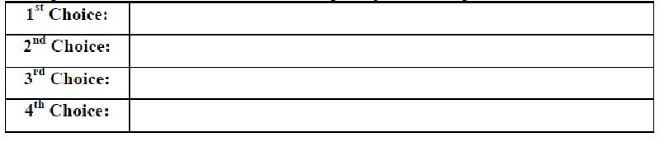

Virtual Hospital

Stock Market Predictor

Additional Remarks/Inputs

Please tell us about any other factors that we should take into consideration(e.g.,if you really would like to work on a project for some particularly convincing reason).

………………………………………………………………………………………………

………………………………………………………………………………………………

………………………………………………………………………………………………

………………………………………………………………………………………………

